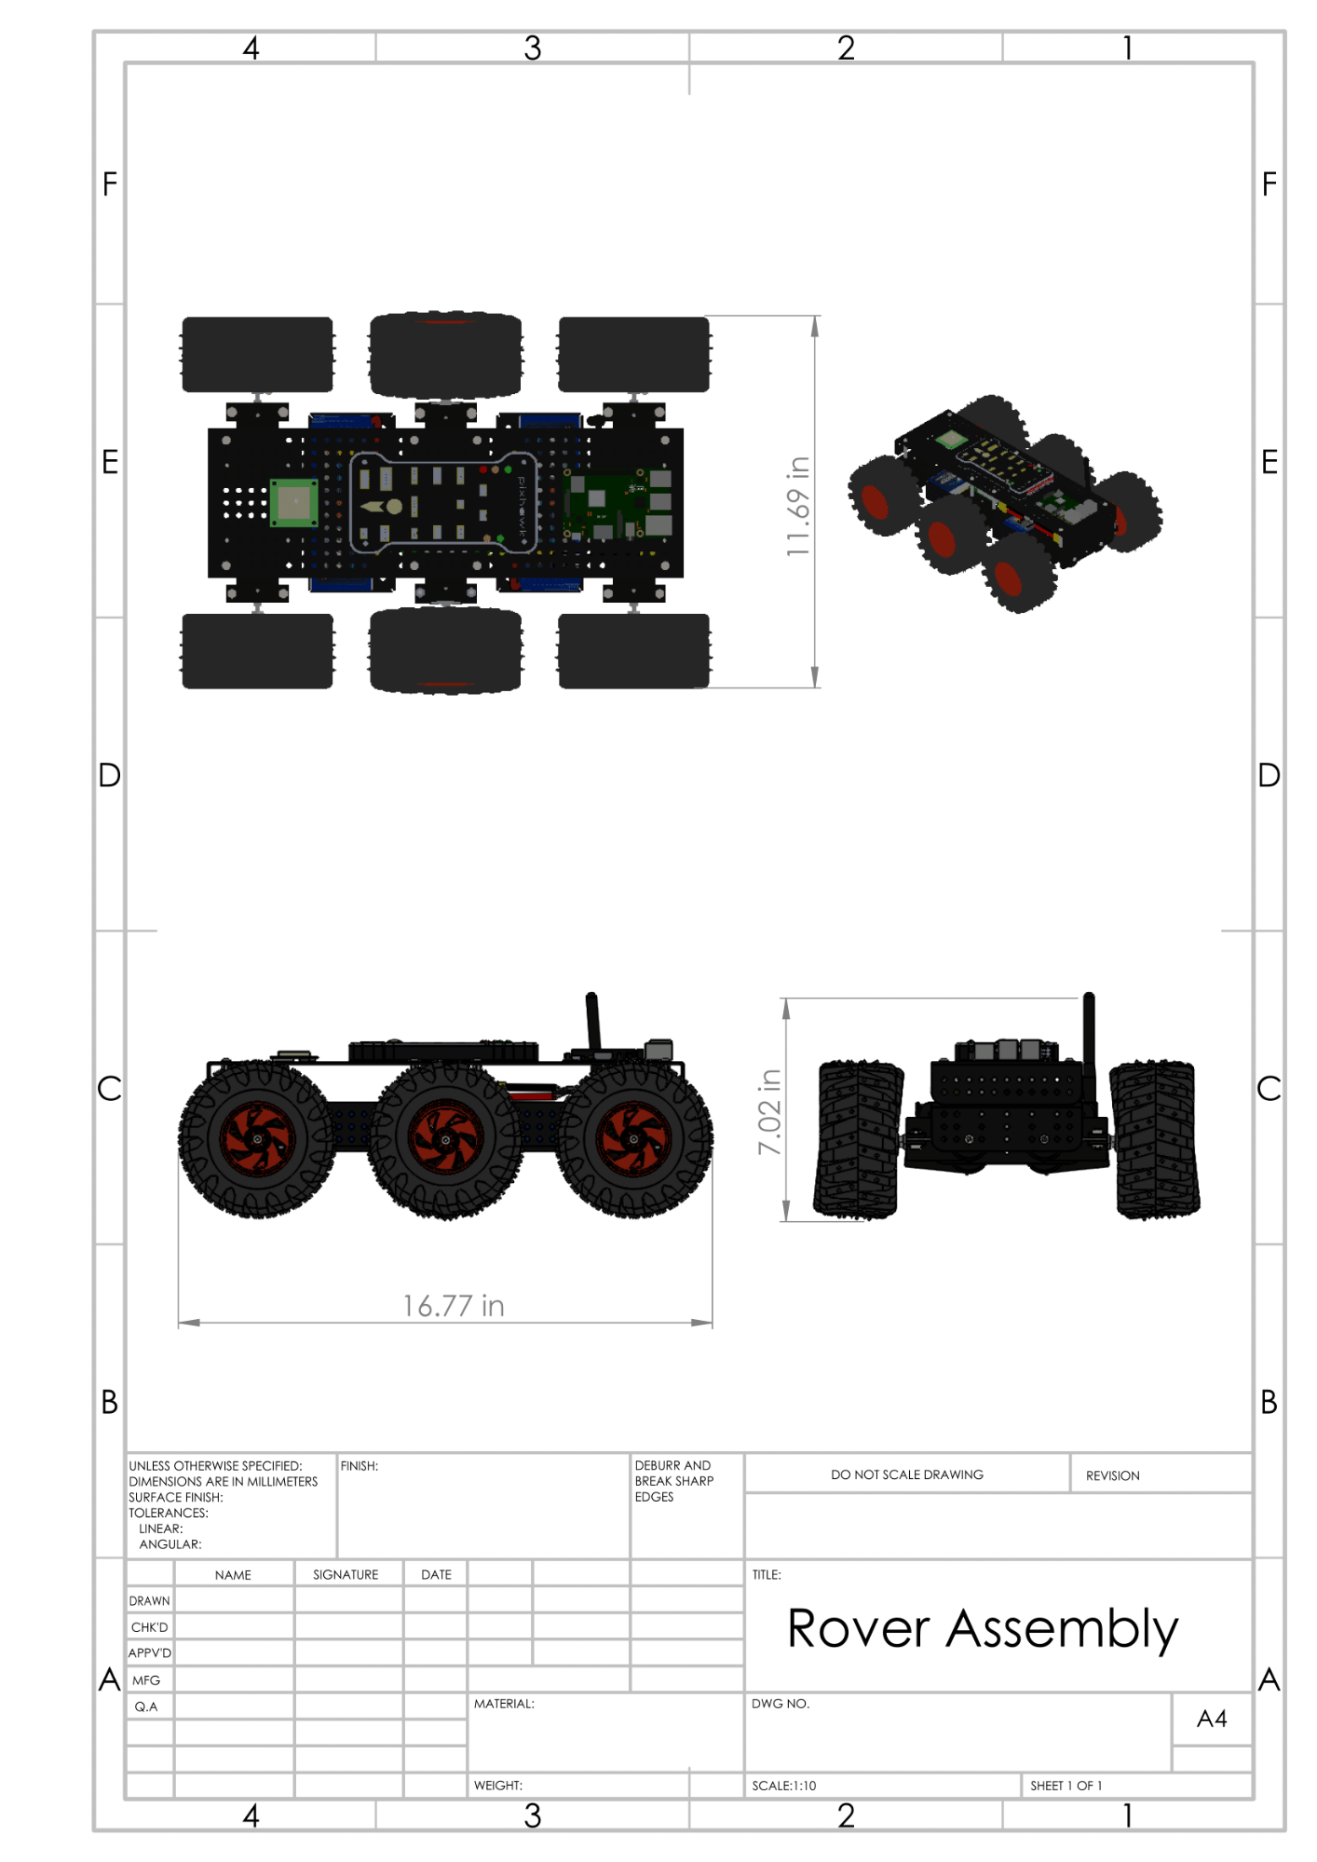

2

pixhawk

U! 69'

7.02 in

16.77 in

FINISH:

DEBURR AND BREAK SHARP EDGES

DO NOT SCALE DRAWING

REVISION

UNLESS OTHERWISE SPECIFIED: DIMENSIONS ARE IN MILLIMETERS SURFACE FINISH: TOLERANCES:

LINEAR: ANGULAR:

NAME

SIGNATURE

DATE

TITLE:

DRAWN

CHK'D

Rover Assembly

APPV'D

MFG

Q.A

MATERIAL:

DWG NO.

**A4**

WEIGHT:

SCALE:1:10

SHEET 1 OF 1